Mods for Yaesu FT-2800
TX Mod FT-2800/M
Hold LOW+D/MR and then press the power on. On the screen you should see "A2" on the readout
Deviation Adjustment ++? for FT-2800M

The information is for the Yaesu FT-2800M
The hidden menu allows for adjustment of deviation, 4 output power levels and a few other things im not sure of. Warning, I take no responsibility for the accuracy of the information or any damage to a radio, but it worked for me. I was told further information can be found in the service manual.
LOW OUTPUT AUDIO?? HERE IS THE FIX
- Hold in "LOW" & "D/MR" buttons, power up radio and release.
- Push "MHZ" button one second.
- Goto selection 35 in menu "D/ASMT"
- Push "MHZ" once.
- Select MOD W in menu
** NOTE ** There is no visual indicator of deviation, a deviation meter should be used for proper alignment.
- To reduce deviation push "REV" button, to increase push "D/MR" button. (multiple times if needed)
- Key up radio and check.
- When deviation is set appropriately push "LOW" button to lock in.
- Push "MHZ" button to return to normal operation.

Yaesu mic mod, FT-2800 and others

Mod for Yaesu MH-48 MIC, used on he FT-2800 and others
The annoying lock function doesnt work, only locks the DTMF buttons and the FUNCTION buttons, leaveing the PTT button unlocked for you to accidentally transmit, potentially embarrasing.
Normally you have to go through the setup on the FT-2800 to lock the PTT, but using my mod all you have to do is use the lock switch.
My mod locks the PTT button and the user programble buttons, but leaves the DTMF buttons unlocked when the lock switch is switched on.
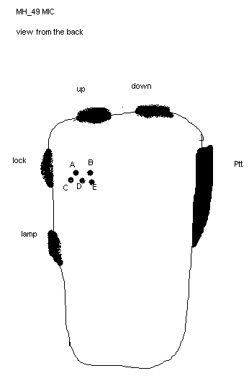
The picture shows the solder blobs..
In the factory setup, in the solder joints near the lock button, only D and E are soldered, in my mod, remove the solder blob from D and put a blob over A.
I only tried the blobs untill I reached the point where all buttons worked unlocked, and the PTT was disabled when locked. I dont know what the other solder jumpers do.

Hidden menu for Yaesu FT-2800M

You can access that new menu by holding all of the front panel keys while powering up the radio. When done, hold the SET button until the menu appear on the display. Instead of 33 menu items, you have 34, and it is called " USER P ". You can turn it ON or OFF but I don't have a clue what it does or mean.
I had no response form Yaesu about it, possibly mean USER PROGRAMMABLE ???
If you find out anything else about it, please let me know !

Yaesu FT-2800M extended TX mod

This MOD is for the NEW Yeasu FT-2800 Hi-Power 2-Meter Mobile and it is easy!
Start by disconnecting power and microphone.
- Remove all screws on bottom of radio and remove bottom cover.
* Careful, the speakers rubber seal my stick to the cover, so take your time and note that the speakers wires are soldered to radio (no connector).
- To make this simple, position the radio with the front facing away from you (bottom up) In the front right corner you will see a set of three solder pads located on the back side of the circuit board for the front display/ controls.
- There is only one solder pad in place from factory (far right side, see photo).
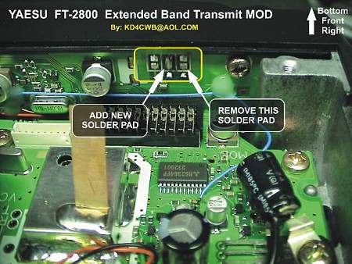
REMOVE this solder pad!
- Bridge the middle solder pad, leave the others un-soldered.
- Reset radio by pressing ALL four white panel buttons while turning power on.
- button labels ---> [MHz] [Rev] [LOW] [D/MR]
Then press the [D/MR] button. The radio will power cycle.
DONE!
NEW TX and RX RANGE is 137.000MHz to 174.000MHz
Enjoy!

ATTENTION
The KB2LJJ takes no responsibility for any damage during the modification or for any wrong information made on this modification.

